Zeitzeugin 1:
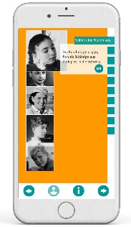
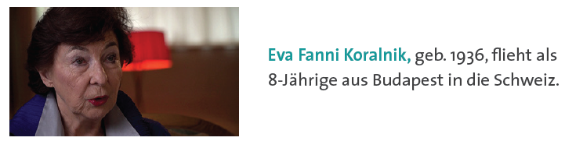
Interessante Informationen:

………………………………………………………………………………………………………………………………………………………………………………………………………………………………………………………………………………………………………………………………………………………………………………………………………………………………………………………………………………
…………………………………………………………………………………………………………………………………………………………
Wichtige Ereignisse im Leben von Eva Fanni Koralnik

………………………………………………………………………………………………………………………………………………………………………………………………………………………………………………………………………………………………………………………………………………………………………………………………………………………………………………………………………………
…………………………………………………………………………………………………………………………………………………………
Die Flucht von Eva Fanni Koralnik

………………………………………………………………………………………………………………………………………………………………………………………………………………………………………………………………………………………………………………………………………………………………………………………………………………………………………………………………………………
…………………………………………………………………………………………………………………………………………………………
Hilfe / Behinderung bei der Flucht

………………………………………………………………………………………………………………………………………………………………………………………………………………………………………………………………………………………………………………………………………………………………………………………………………………………………………………………………………………
…………………………………………………………………………………………………………………………………………………………
Flucht heute
………………………………………………………………………………………………………………………………………………………………………………………………………………………………………………………………………………………………………………………………………………………………………………………………………………………………………………………………………………
…………………………………………………………………………………………………………………………………………………………
3 Fragen, die ich selbst gerne an Frau Koralnik stellen würde:

Zeitzeuge 2: Paul Schaffer
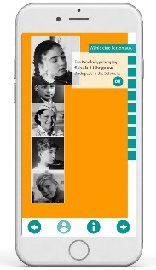
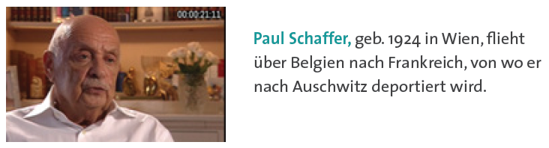
Interessante Informationen:

………………………………………………………………………………………………………………………………………………………………………………………………………………………………………………………………………………………………………………………………………………………………………………………………………………………………………………………………………………
…………………………………………………………………………………………………………………………………………………………
Wichtige Ereignisse im Leben von Herr Schaffner:

………………………………………………………………………………………………………………………………………………………………………………………………………………………………………………………………………………………………………………………………………………………………………………………………………………………………………………………………………………
…………………………………………………………………………………………………………………………………………………………
Die Flucht von Paul Schaffer

………………………………………………………………………………………………………………………………………………………………………………………………………………………………………………………………………………………………………………………………………………………………………………………………………………………………………………………………………………
…………………………………………………………………………………………………………………………………………………………
Hilfe / Behinderung bei der Flucht

………………………………………………………………………………………………………………………………………………………………………………………………………………………………………………………………………………………………………………………………………………………………………………………………………………………………………………………………………………
…………………………………………………………………………………………………………………………………………………………
Flucht heute
………………………………………………………………………………………………………………………………………………………………………………………………………………………………………………………………………………………………………………………………………………………………………………………………………………………………………………………………………………
…………………………………………………………………………………………………………………………………………………………
3 Fragen, die ich selbst gerne an Herrn Schaffer stellen würde:

Zeitzeugin 3: Sophie Haber
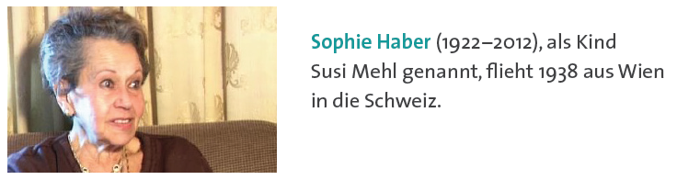
Interessante Informationen:

………………………………………………………………………………………………………………………………………………………………………………………………………………………………………………………………………………………………………………………………………………………………………………………………………………………………………………………………………………
…………………………………………………………………………………………………………………………………………………………
Wichtige Ereignisse im Leben von Sophie Haber

………………………………………………………………………………………………………………………………………………………………………………………………………………………………………………………………………………………………………………………………………………………………………………………………………………………………………………………………………………
…………………………………………………………………………………………………………………………………………………………
Die Flucht von Sophie Haber

………………………………………………………………………………………………………………………………………………………………………………………………………………………………………………………………………………………………………………………………………………………………………………………………………………………………………………………………………………
…………………………………………………………………………………………………………………………………………………………
Hilfe / Behinderung bei der Flucht

………………………………………………………………………………………………………………………………………………………………………………………………………………………………………………………………………………………………………………………………………………………………………………………………………………………………………………………………………………
…………………………………………………………………………………………………………………………………………………………
Flucht heute
………………………………………………………………………………………………………………………………………………………………………………………………………………………………………………………………………………………………………………………………………………………………………………………………………………………………………………………………………………
…………………………………………………………………………………………………………………………………………………………
3 Fragen, die ich selbst gerne an Frau Haber stellen würde:

Zeitzeuge 4: Hellmut Stern
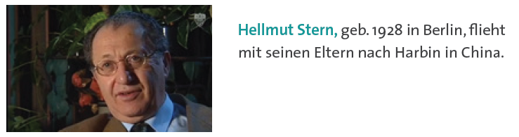
Interessante Informationen:

………………………………………………………………………………………………………………………………………………………………………………………………………………………………………………………………………………………………………………………………………………………………………………………………………………………………………………………………………………
…………………………………………………………………………………………………………………………………………………………
Wichtige Ereignisse im Leben von Hellmut Stern

………………………………………………………………………………………………………………………………………………………………………………………………………………………………………………………………………………………………………………………………………………………………………………………………………………………………………………………………………………
…………………………………………………………………………………………………………………………………………………………
Die Flucht von Hellmut Stern

………………………………………………………………………………………………………………………………………………………………………………………………………………………………………………………………………………………………………………………………………………………………………………………………………………………………………………………………………………
…………………………………………………………………………………………………………………………………………………………
Hilfe / Behinderung bei der Flucht

………………………………………………………………………………………………………………………………………………………………………………………………………………………………………………………………………………………………………………………………………………………………………………………………………………………………………………………………………………
…………………………………………………………………………………………………………………………………………………………
Flucht heute
………………………………………………………………………………………………………………………………………………………………………………………………………………………………………………………………………………………………………………………………………………………………………………………………………………………………………………………………………………
…………………………………………………………………………………………………………………………………………………………
3 Fragen, die ich selbst gerne an Herrn Stern stellen würde:

Zeitzeugin 5: Abraham Gafni
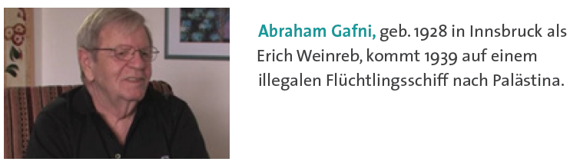
Interessante Informationen:

………………………………………………………………………………………………………………………………………………………………………………………………………………………………………………………………………………………………………………………………………………………………………………………………………………………………………………………………………………
…………………………………………………………………………………………………………………………………………………………
Wichtige Ereignisse im Leben von Abraham Gafni

………………………………………………………………………………………………………………………………………………………………………………………………………………………………………………………………………………………………………………………………………………………………………………………………………………………………………………………………………………
…………………………………………………………………………………………………………………………………………………………
Die Flucht von Abraham Gafni

………………………………………………………………………………………………………………………………………………………………………………………………………………………………………………………………………………………………………………………………………………………………………………………………………………………………………………………………………………
…………………………………………………………………………………………………………………………………………………………
Hilfe / Behinderung bei der Flucht

………………………………………………………………………………………………………………………………………………………………………………………………………………………………………………………………………………………………………………………………………………………………………………………………………………………………………………………………………………
…………………………………………………………………………………………………………………………………………………………
Flucht heute
………………………………………………………………………………………………………………………………………………………………………………………………………………………………………………………………………………………………………………………………………………………………………………………………………………………………………………………………………………
…………………………………………………………………………………………………………………………………………………………
3 Fragen, die ich selbst gerne an Herrn Gafni stellen würde:

